**Jan 2nd 2023**

**Assignment Matrix**

**Assignment1:-**

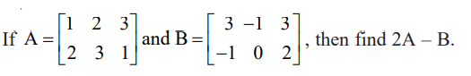

**Assignment 2:-**

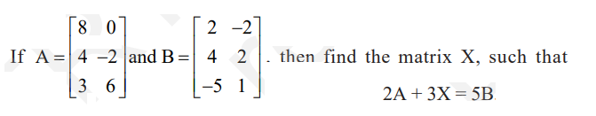

**Assignment 3:-**

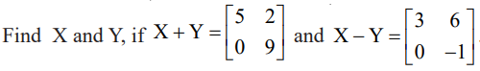

**Assignment 4:-**

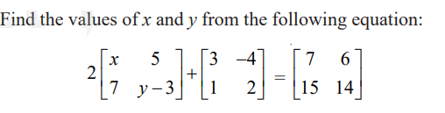

**Assignment 5:-**

**Two farmers Ramkishan and Gurcharan Singh cultivates only three varieties of rice namely Basmati, Permal and Naura. The sale (in Rupees) of these varieties of rice by both the farmers in the month of September and October are given by the following matrices A and B.**

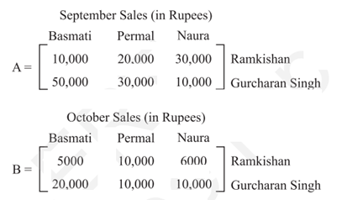

1. **Find the combined sales in September and October for each farmer in each variety.**
2. **Find the decrease in sales from September to October.**
3. **If both farmers receive 2% profit on gross sales, compute the profit for each farmer and for each variety sold in October.**

**Assignment 6:-**

**You have a Drone Manufacturing Factory od 3 Verities say F1,F2,F3.**

**Row material B1, B2, B3, B4 are imported which is required to produce semi-finished product Say M1,M2,M3.**

**These semi-finished Product M1,M2,M3 can use to complete the Finial fished Drone Product say F1,F2,F3.**

|  |  |  |  |
| --- | --- | --- | --- |
| With unit Quantity of Row Material | Quantity of Semi-finished product produced | | |
| M1 | M2 | M3 |
| B1 | 1 | 0 | 1 |
| B2 | 2 | 1 | 1 |
| B3 | 0 | 1 | 1 |
| B4 | 1 | 1 | 2 |

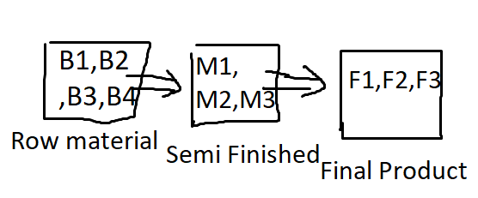

**The production line detail as below:-**

|  |  |  |  |
| --- | --- | --- | --- |
| With unit Quantity of semi- finished product | Quantity of Final product produced | | |
| F1 | F2 | F3 |
| M1 | 1 | 2 | 1 |
| M2 | 2 | 3 | 1 |
| M3 | 4 | 2 | 2 |

You want to produce Final Drone of different models as Required Quantity: - **F1=100, F2=80, F3=60.**

Calculate the required Quantity of Imported of Row material (B1, B2, B3, B4) to complete the production of Finish Drone models ?